Name Bilal Abid Abbasi

Class 1 semester

Pf lab assignment

Iqra University
Islamabad Campus Fall Semester 2026

LAB TASK 8
Course Code: CSC 131 | Course Title: Programming Fundamental
Teacher’s Name: Mr. Ilyas Badshah | Total Marks: 10
Deadline: 10 Jan 2026 | Time: 11 59 pm

1. Largest Number in Array
#include <iostream>
using namespace std;

int main() {
int arr[5], largest;

cout << "Enter 5 numbers:\n";
for(int i = 0; i < 5; i++)
cin >> arr[i];

largest = arr[0];
for(int i = 1; i < 5; i++) {
if(arr[i] > largest)
largest = arr[i];
}

cout << "Largest number = " << largest;
return 0;
}
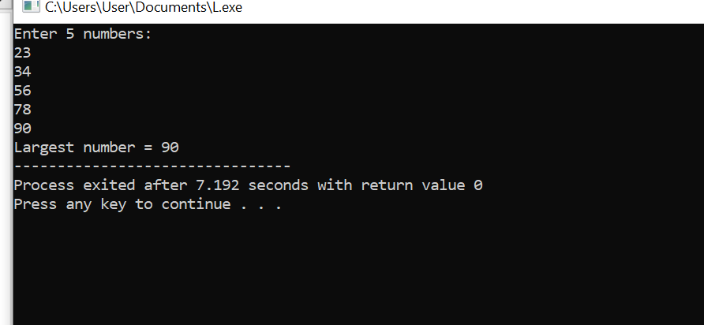

2. Average of Array Elements
#include <iostream>
using namespace std;

int main() {
int arr[5], sum = 0;
float avg;

cout << "Enter 5 numbers:\n";
for(int i = 0; i < 5; i++) {
cin >> arr[i];
sum += arr[i];
}

avg = sum / 5.0;
cout << "Average = " << avg;
return 0;
}
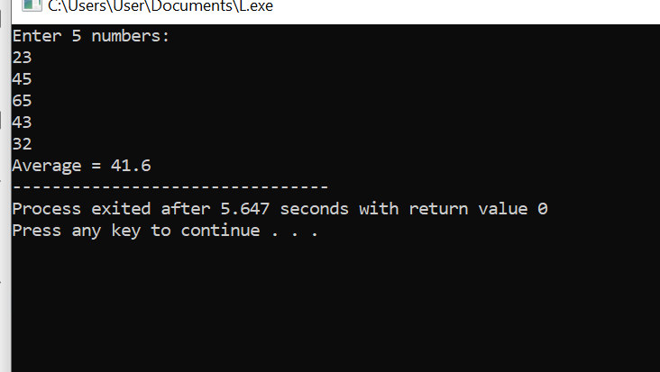

3. Reverse Array Elements
#include <iostream>
using namespace std;

int main() {
int arr[5], temp;

cout << "Enter 5 elements:\n";
for(int i = 0; i < 5; i++)
cin >> arr[i];

for(int i = 0; i < 5/2; i++) {
temp = arr[i];
arr[i] = arr[4 - i];
arr[4 - i] = temp;
}

cout << "Reversed Array:\n";
for(int i = 0; i < 5; i++)
cout << arr[i] << " ";

return 0;
}
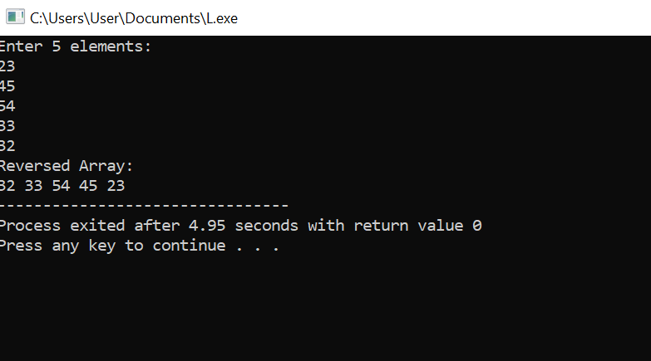

4. Check if Element is Present
#include <iostream>
using namespace std;

int main() {
int arr[5], key;
bool found = false;

cout << "Enter 5 elements:\n";
for(int i = 0; i < 5; i++)
cin >> arr[i];

cout << "Enter element to search: ";
cin >> key;

for(int i = 0; i < 5; i++) {
if(arr[i] == key) {
cout << "Element found at index " << i;
found = true;
break;
}
}

if(!found)
cout << "Element not found";

return 0;
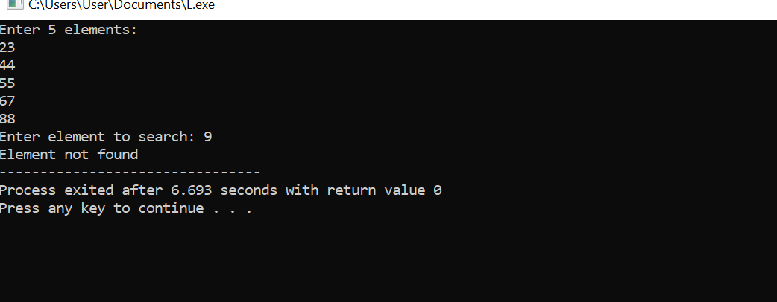
}

5. Sort Array (Ascending & Descending)
#include <iostream>
using namespace std;

int main() {
int arr[5], temp;

cout << "Enter 5 elements:\n";
for(int i = 0; i < 5; i++)
cin >> arr[i];

// Ascending order
for(int i = 0; i < 5-1; i++) {
for(int j = i+1; j < 5; j++) {
if(arr[i] > arr[j]) {
temp = arr[i];
arr[i] = arr[j];
arr[j] = temp;
}
}
}

cout << "Ascending order: ";
for(int i = 0; i < 5; i++)
cout << arr[i] << " ";

// Descending order
for(int i = 0; i < 5/2; i++) {
temp = arr[i];
arr[i] = arr[5-1-i];
arr[5-1-i] = temp;
}

cout << "\nDescending order: ";
for(int i = 0; i < 5; i++)
cout << arr[i] << " ";

return 0;
}
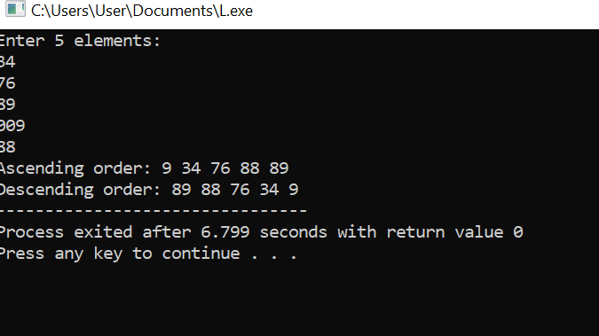

6. Remove Duplicates in Array
#include <iostream>
using namespace std;

int main() {
int arr[5], n = 5;
int i, j, k;

cout << "Enter 5 elements:\n";
for(i = 0; i < n; i++)
cin >> arr[i];

for(i = 0; i < n; i++) {
for(j = i+1; j < n; ) {
if(arr[i] == arr[j]) {
// Shift elements left
for(k = j; k < n-1; k++)
arr[k] = arr[k+1];
n--; // reduce array size
} else {
j++;
}
}
}

cout << "Array after removing duplicates: ";
for(i = 0; i < n; i++)
cout << arr[i] << " ";

return 0;
}
